**Lauren Pelayo** (Diagrams & Data)

**Thomas Lindholm** (Calculations & Analysis)

**Alex Lundin** (Diagrams)

PHYS 2125.104.603

TA: Matthew Fong

Lab Section: #603

Sep. 22, 2015

**Lab 2: Vectors**

**Table of Contents**

**1.) Analysis Questions**

**2.) Data**

**3.) Calculations**

1.) Analysis:

**(Q6.0.3)**

1. As m1 increases in table 2, the elevation and incline angle increases to compensate for the change in mass



Free Body Diagram 1: Flat Track.

1. 

Free Body Diagram 2: Inclined Track.

1. alpha shown above
2. The angle between the negative normal force and weight on track is alpha

|  |  |  |  |  |  |  |  |  |  |
| --- | --- | --- | --- | --- | --- | --- | --- | --- | --- |
| **Trial** | **mass M1** | **Mass M2** | **Force M1** | **Force M2** | **Angle** | **M1** | | **M2** | |
|  |  |  |  |  |  | **X** | **Y** | **X** | **Y** |
| 1 | 0.031 | 0.030 | 0.299 | 0.296 | 0.000 | 0.299 | 0.000 | 0.296 | 0.000 |
| 2 | 0.036 | 0.030 | 0.348 | 0.296 | 0.010 | 0.348 | 0.003 | 0.296 | 0.003 |
| 3 | 0.041 | 0.030 | 0.397 | 0.296 | 0.022 | 0.397 | 0.009 | 0.296 | 0.009 |
| 4 | 0.046 | 0.030 | 0.446 | 0.296 | 0.040 | 0.446 | 0.018 | 0.296 | 0.018 |
| 5 | 0.051 | 0.030 | 0.495 | 0.296 | 0.050 | 0.494 | 0.025 | 0.296 | 0.025 |
| 6 | 0.056 | 0.030 | 0.544 | 0.296 | 0.062 | 0.543 | 0.034 | 0.295 | 0.034 |
| **UNITS** | **(kg)** | | **(N)** | | **(°)** | **(N)** | | **(N)** | |

Table 1: X and Y components and Resultant of weight on glider.

*F(r) = resultant force, F(n) = magnitude of the Normal Force

*You’ll also notice how the magnitude of M1 equivocates to M2 plus the normal force implying that there is only a negligible amount of force acting within the system.

**(||M1||) ≈ (||M2|| + F(n))**

|  |  |  |  |  |
| --- | --- | --- | --- | --- |
| **F(n)** | **||M1||** | **||M2||** | **||M2||+Fn** | **F(r )** |
|  |  |  |  |  |
| 0.000 | 0.299 | 0.296 | 0.296 | 0.003 |
| 0.037 | 0.348 | 0.296 | 0.333 | 0.015 |
| 0.083 | 0.397 | 0.296 | 0.379 | 0.017 |
| 0.148 | 0.446 | 0.296 | 0.445 | 0.001 |
| 0.185 | 0.495 | 0.297 | 0.482 | 0.013 |
| 0.232 | 0.544 | 0.297 | 0.529 | 0.015 |
| **(N)** | | **(N)** | | **(N)** |

Table 2: Resultant Force from Table 1

1.) Analysis:

**(Q6.0.4)**

1. Free Body Diagrams (shown in each Diagram below)
2. X & Y Axes Labels (shown in each Diagram below)
3. X & Y vector forces components (shown in each Diagram below)



Free Body Diagram 3: Trial 1.



Free Body Diagram 4: Trial 2.



Free Body Diagram 5: Trial 3.



Free Body Diagram 6: Trial 4.

1.) Analysis:

**(Q6.0.4)**

1. Graphical Solutions



Graphical Solution 1: Trial 1.

Graphical Solution 2: Trial 2.

Graphical Solution 3: Trial 3.

Graphical Solution 4: Trial 4.

1.) Analysis:

**(Q6.0.4)**

1. Component addition

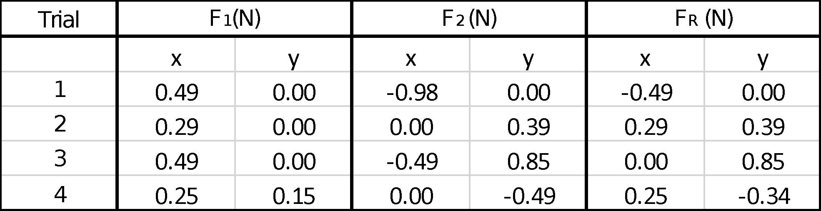

Table 3: Component Addition.

**(Q6.0.5)**

1. Quantities
   1. Scalar: distance ($500 m$), mass ($50 grams$)
   2. Vector: Acceleration (9.8 $m/s^{2}$), Velocity ($m/s)$
2. Labeled axes for the diagrams, they coincide with the table
3. We resolved the vectors in the following table
   1. Resultant Vector

|  |  |  |  |  |  |  |  |
| --- | --- | --- | --- | --- | --- | --- | --- |
| **A** | | **B** | | **Resultant vector** | | **||Resultant||** | **Resultant** |
| **X** | **Y** | **X** | **Y** | **X** | **Y** | **Vector** | **Angle** |
| -18.7938 | -6.8404 | 6.8404 | -18.7938 | -11.953 | -25.643 | 28.284 | 245° |

Table 4: X and Y components and Resultant

|  |  |  |  |  |  |  |  |
| --- | --- | --- | --- | --- | --- | --- | --- |
| **C** | | **D** | | **Resultant vector** | | **||Resultant||** | **Resultant** |
| **X** | **Y** | **X** | **Y** | **X** | **Y** | **Vector** | **Angle** |
| -50 | 86.6025 | 45 | 0 | -5 | 86.6025 | 86.746 | 93.299° |

Table 5: X and Y components and Resultant

|  |  |  |  |  |  |  |  |
| --- | --- | --- | --- | --- | --- | --- | --- |
| **E** | | **F** | | **Resultant vector** | | **||Resultant||** | **Resultant** |
| **X** | **Y** | **X** | **Y** | **X** | **Y** | **Vector** | **Angle** |
| 43.301 | 25 | 100 | 0 | 142.301 | 25 | 145.4656 | 9.89605° |

Table 6: X and Y components and Resultant

|  |  |  |  |  |  |
| --- | --- | --- | --- | --- | --- |
| **G** | | **H** | | **I** | |
| **X** | **Y** | **X** | **Y** | **X** | **Y** |
| -25.9807 | -15 | 10 | 0 | -10 | 17.3205 |

Table 7: X and Y components and Resultant

|  |  |  |  |
| --- | --- | --- | --- |
| **Resultant vector** | | **||Resultant||** | **Resultant** |
| **X** | **Y** | **Vector** | **Angle** |
| -25.981 | 2.3205 | 26.0844 | 174.896159 |

Table 8: X and Y components and Resultant

* 1. Graphically



Graphical Solution 5.



Graphical Solution 6.



Graphical Solution 7.



Graphical Solution 8.

2.) Data:

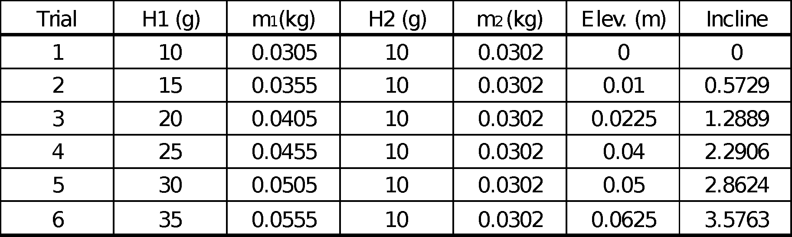

Table 9: Data table for air track measurements.

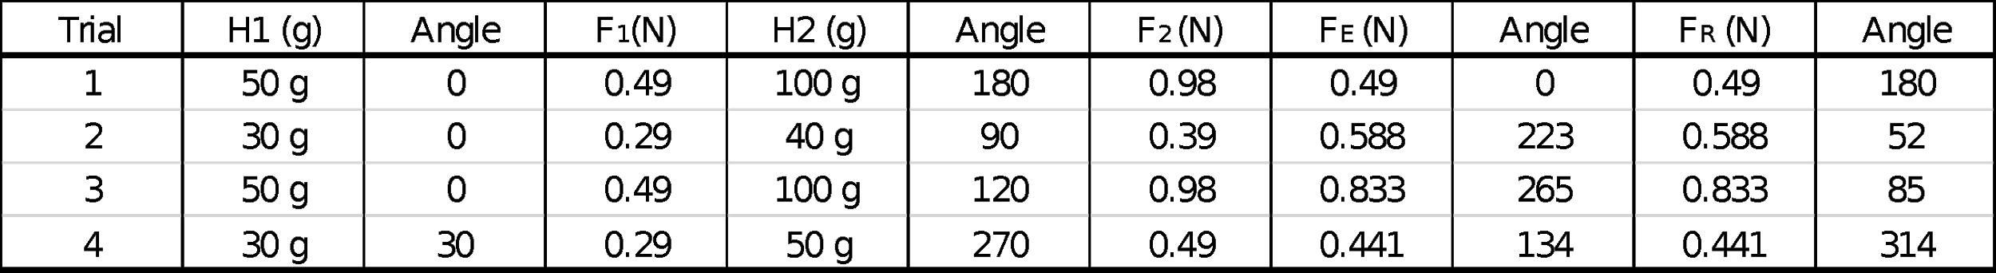

Table 10: Data table for force table measurements.

3.) Calculations:

Sample calculations from:

Free body diagram trial 3

$A_{y}=$ $Asinθ$

$F_{y}=.88sin(92)=0.83$

$A_{x}=$ $Acosθ$

$F_{x}=.83cos(92)=-0.03$

*A*= $\sqrt{(A_{x}^{}){}_{}^{2}+(A_{y}){}^{2}}$